Project Design Phase Solution Architecture

Date | 12/09/2026
Student Name | Navya Sri Tangellamudi
Project Name | Intergalactic Space Travel Request System (ISTR)
Maximum Marks | 4 Marks

Solution Architecture:
Solution architecture is a complex process – with many sub-processes – that bridges the gap between business problems and technology solutions. For ISTR, its goals are to:
- Find the best tech solution (ServiceNow custom table + Flow Designer) to solve the interplanetary mission-approval problem.
- Describe the structure, characteristics, behavior, and other aspects of ISTR to project stakeholders (Requester, Manager, Finance Officer, Mission Control, Admin).
- Define features, development phases, and solution requirements for the ISTR platform.
- Provide specifications according to which ISTR is defined, managed, and delivered across Dev, Test, and Prod instances.

Solution Architecture Diagram (Data Flow View):
This view shows how a mission request moves through the platform end to end: from submission, through role-based approval routing, SLA tracking, and audit logging, to launch and stakeholder notification.

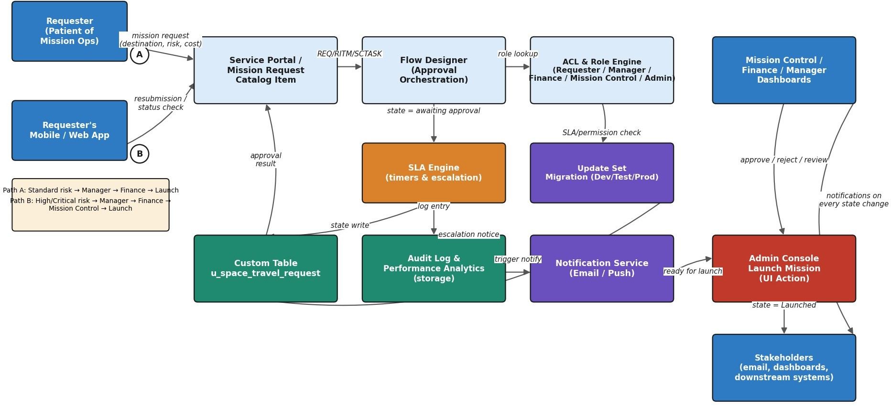

Figure 1: Architecture and data flow of the ISTR mission-approval application

Layered (3-Tier) Component Architecture:
This view organizes the same system by architectural layer — Presentation, Application/Logic, and Data — showing which ServiceNow components live in each tier and how they connect vertically.
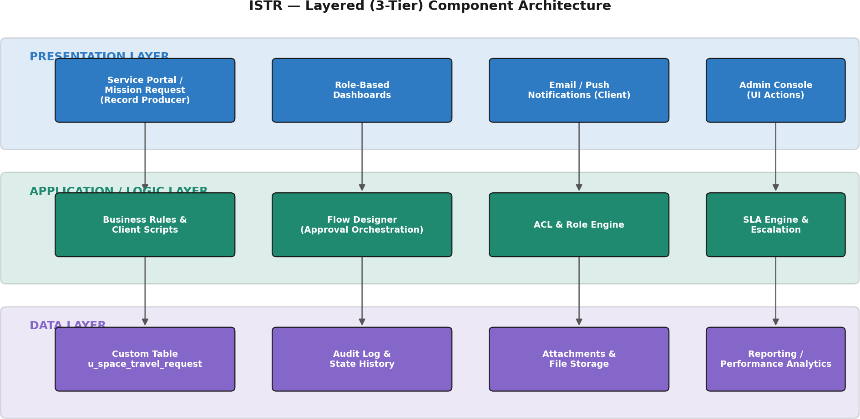

Figure 2: ISTR 3-tier component architecture

Mission Approval Sequence (Swimlane):
This view traces a single mission request over time across the five actor roles, showing exactly which step each stakeholder performs and where the flow branches for High/Critical risk missions.
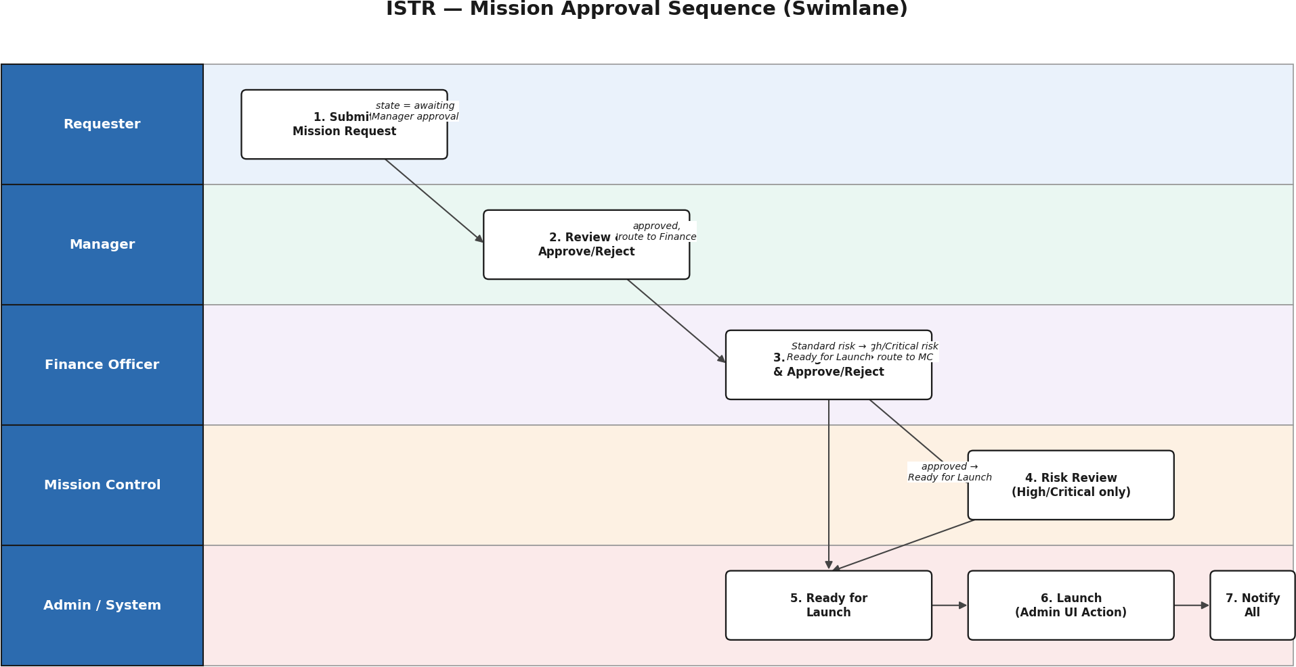

Figure 3: End-to-end approval sequence across Requester, Manager, Finance, Mission Control, and Admin

Deployment & Environment Flow:
This view shows how ISTR is built and promoted across ServiceNow instances — Dev, Test, and Prod — via Update Sets, and where external services (email notifications, MID Server/API integrations) connect in.
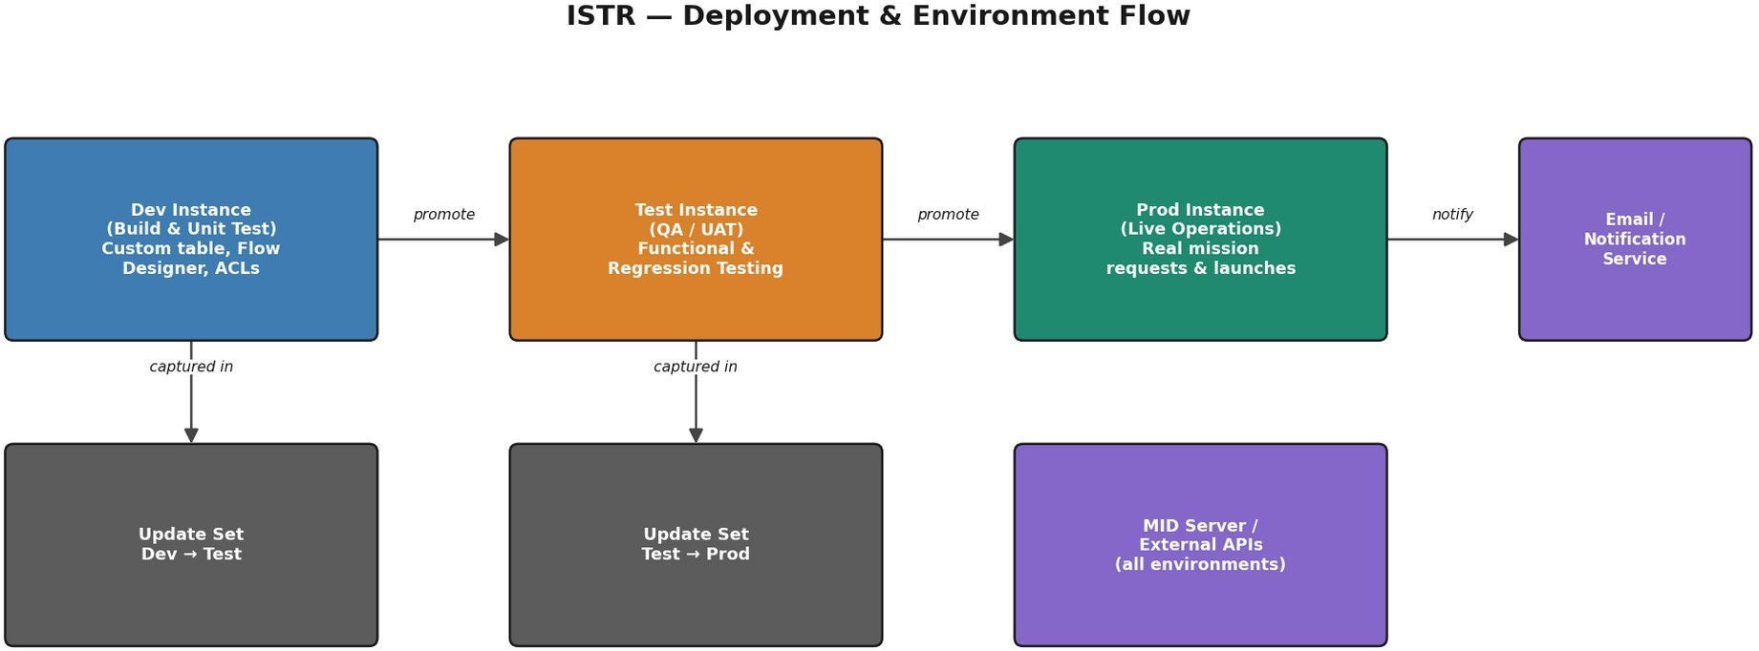

Figure 4: ISTR deployment pipeline across Dev, Test, and Prod instances

References:
- https://developer.servicenow.com/dev.do (ServiceNow Developer Documentation — Flow Designer & Platform Architecture)
- https://www.servicenow.com/products/application-development.html

